BIT 4107 – Mobile Application Development
ENHANCED PROFESSIONAL STUDENT LOGBOOK
Student Name: GRACE MUINDI
Admission Number: BIT/2024/59311
School/Faculty: SCHOOL OF COMPUTING AND INFORMATICS
Program: MOBILE APPLICATION DEVELOPMENT
Academic Year: YEAR 3
Semester: 3.2
Lecturer: MR MICHAEL NYORO
Phone Number:0741592395

Table of Contents
Week 1: Introduction to Mobile Application Development 4
Practical Activities Undertaken 4
Tools/Software Used 4
Week 2: Mobile Development Environment 4
Practical Activities Undertaken 4
Tools/Software Used 4
Week 3: User Interface Design 4
Practical Activities Undertaken 4
Tools/Software Used 4
Practical Activities Undertaken 5
Tools/Software Used 5
Week 5: Data Management 5
Practical Activities Undertaken 5
Tools/Software Used 5
Practical Activities Undertaken 6
Tools/Software Used 6
Week 7: Application Architecture 6
Practical Activities Undertaken 6
Tools/Software Used 6
Week 8: Project Planning 6
Practical Activities Undertaken 6
Tools/Software Used 6
Week 9: Device Features and Sensors 6
Practical Activities Undertaken 6
Tools/Software Used 6
Week 10: Notifications and Background Services 6
Practical Activities Undertaken 6
Tools/Software Used 6
Week 11: Mobile Security 6
Practical Activities Undertaken 6
Tools/Software Used 7
Practical Activities Undertaken 7
Tools/Software Used 7
Practical Activities Undertaken 7
Tools/Software Used 7
Personal Reflection 7
Week 14: Final Project Presentation 8
Practical Activities Undertaken 8
Tools/Software Used 8
Personal Reflection 8
Semester Project Tracking 8
Project Title 8
Project Objectives 8
Project Requirements 8
Development Milestones 8
Testing Results 8
Lessons Learned 9
Future Improvements 9
End of Semester Reflection 9
Summary of Skills Acquired 9
Most Interesting Topic 9
Major Challenges Faced 9
How Challenges Were Overcome 9
Professional Growth Achieved 9
Overall Course Experience 9
Final Approval 11

Week 3: User Interface Design
FIG1:LOGIN SCREEN UI

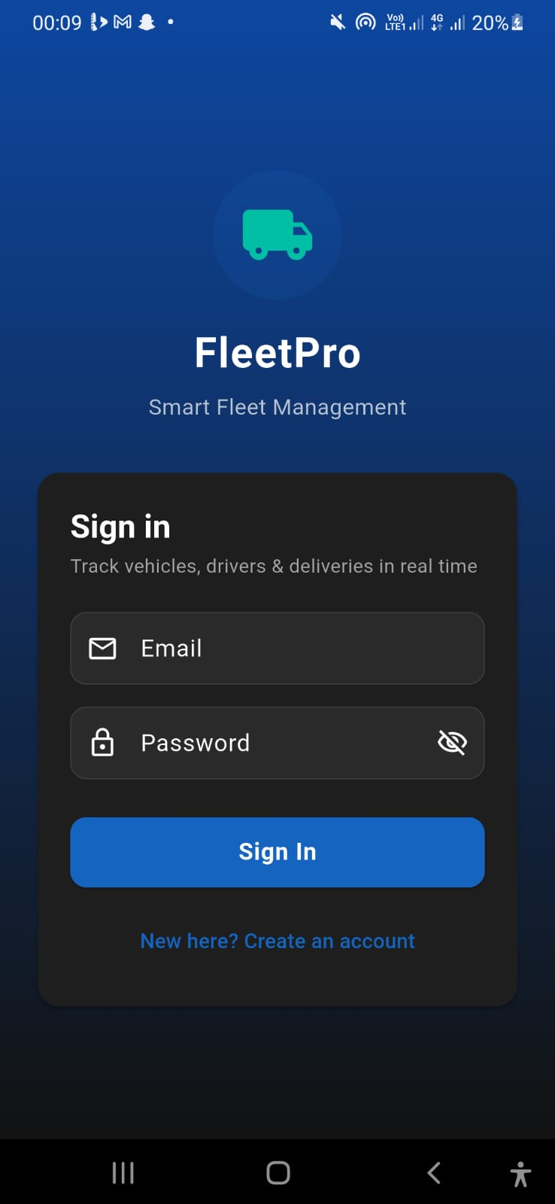

FIG 2: REGISTRATION UI
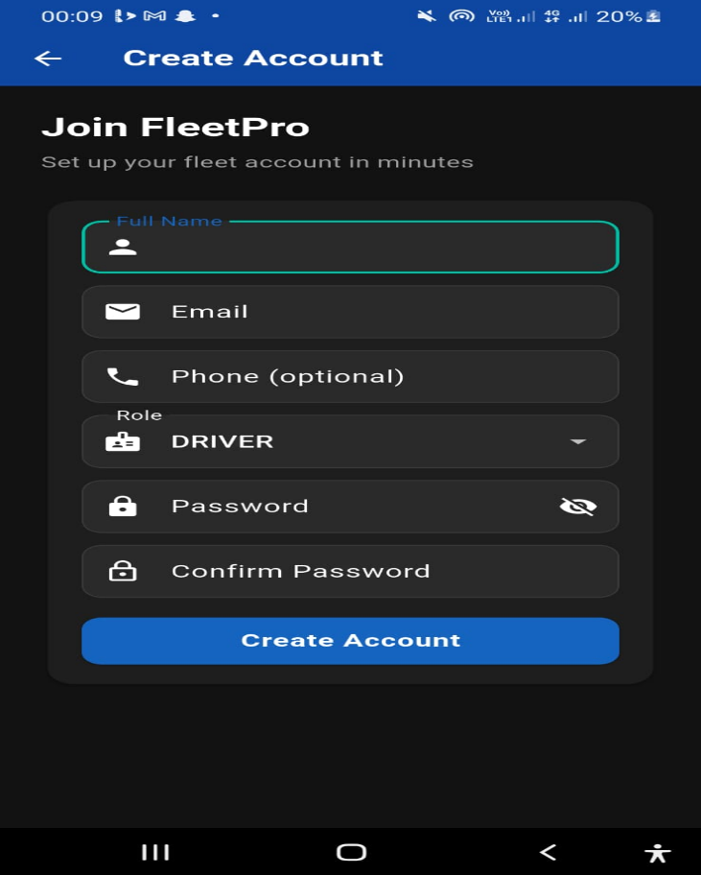
FIG 3: DRIVER DASHBOARD UI
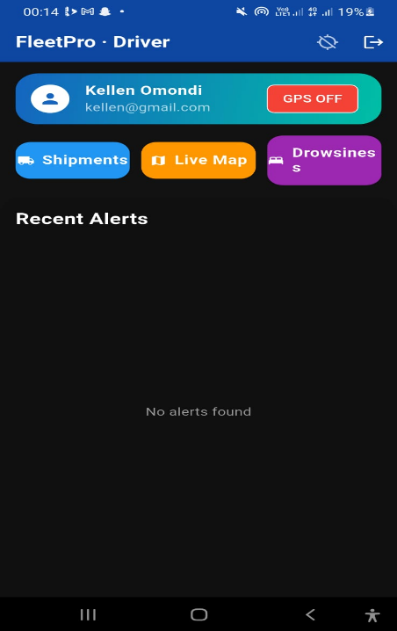
FIG 4: MANAGER DASHBOARD UI

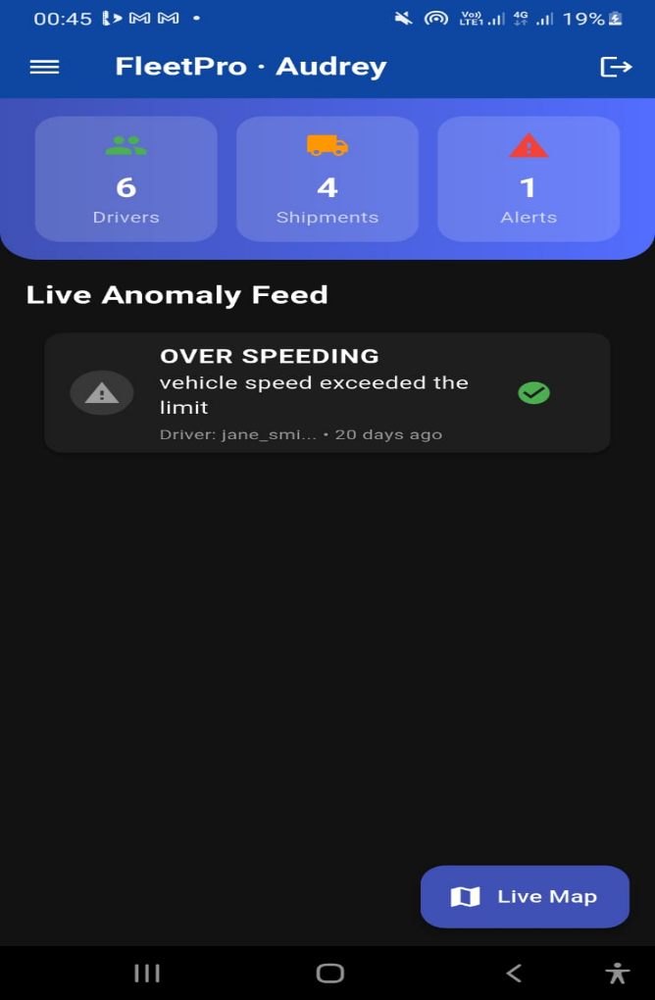

FIG 5: ADMIN DASHBOARD UI

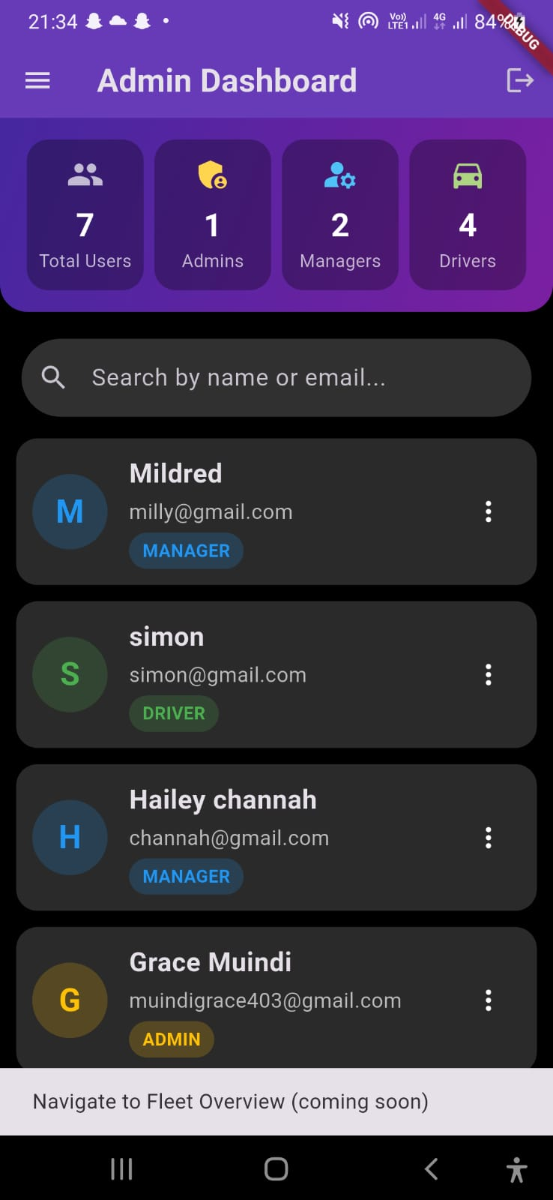

Tools/Software Used

Flutter – Material Design widgets

VS Code – Code editor

Flutter DevTools – Widget inspector (for layout testing)

Google Material Icons – Icon library

Personal Reflection

Designing screens with Flutter is fast. Hot reload lets me see changes instantly. The dark theme looks professional. Creating reusable card components saved time.

Week 4: Event Handling and User Interaction

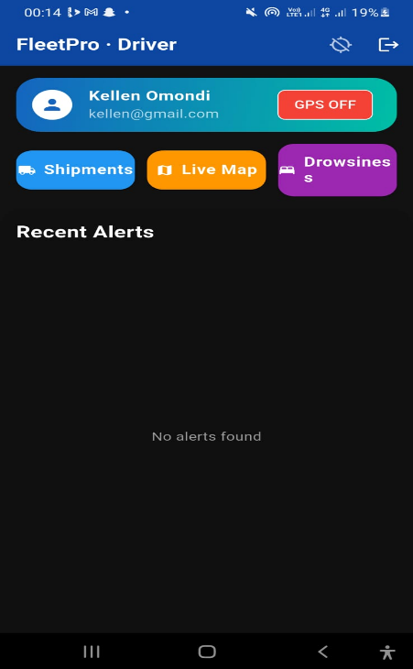

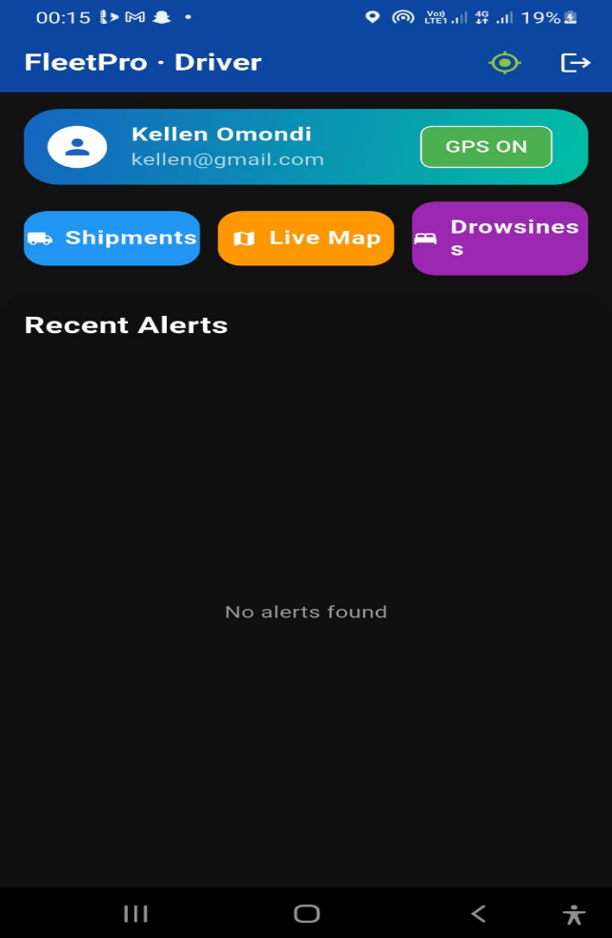

FIG 4:1: GPS toggle icon – Before: Red (GPS OFF); After: Green (GPS ON) with Chip change.
Tools/Software Used
- Flutter – Gesture Detector, TextEditingController, Snack Bar, Icon Button, PopupMenuButton
- Provider – State management for login status
- VS Code Debugger – Breakpoints for event debugging

Personal Reflection
Events are easy to handle with Flutter. The GPS toggle works nicely with Provider state management. Navigation between screens is smooth. Snack bars provide good user feedback.
Week 5: Data Management

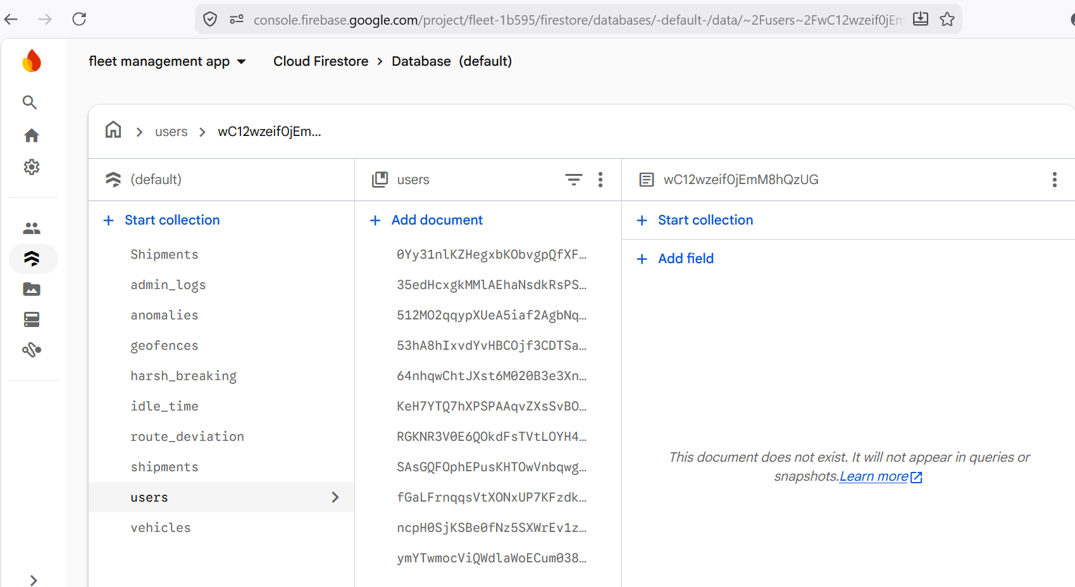

This is a firebase console screenshot showing user collection, shipments, anomalies, vehicles etc. showing the firebase data management.
Tools/Software Used
- Firebase Console – Fire store Database management
- VS Code – Dart model creation
- Firebase SDK – cloud_firestore package
Personal Reflection
Firebase is perfect for this app. Real-time sync means no backend coding. I only need to design data models. The collections (users, shipments, anomalies) cover all core features.
Week 6: Networking and APIs
Why Does My Fleet Management App Require Networking?
The Fleet Management System requires networking for the following critical reasons:
- Real-time Location Sharing – Driver's GPS location must be sent to the cloud so managers can view it on a live map.
- User Authentication – Login and registration require network communication with Firebase Authentication.
- Database Operations – All CRUD operations (insert, update, delete, read) for users, shipments, anomalies, vehicles, and geofences are performed via Fire store.
- Push Notifications – Anomaly alerts (over speeding, drowsiness, etc.) are sent to managers via Firebase Cloud Messaging (FCM).
- Multi-device Synchronization – Managers and drivers using different devices need to see the same data in real-time.
- Geofencing Alerts – When a driver enters/exits a geofenced zone, the system must send an alert across the network.
- Analytics & Reporting – Reports require querying Fire store data over the network.
- Cloud Backup – All fleet data is stored in Firebase, requiring network access for backup and retrieval.
NETWORK CONNECTION STRING
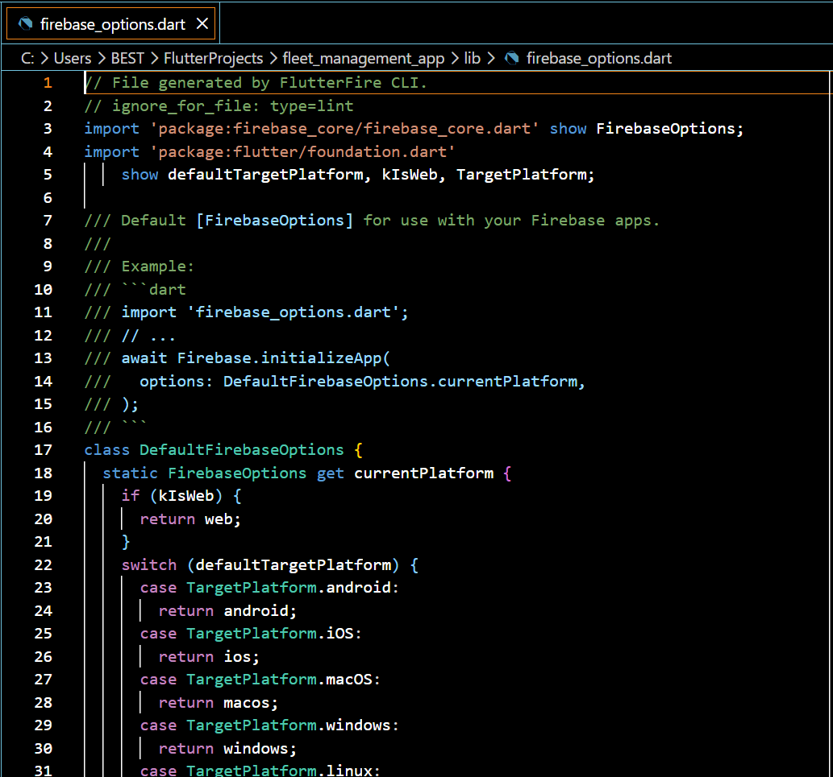
Tools/Software Used
- Firebase CLI – firebase-tools for project configuration
- Flutter Fire CLI – flutter fire for Flutter-Firebase integration
- Firebase Console – Authentication, Fire store, Realtime Database
- VS Code – Code editing and debugging
- Flutter DevTools – Network tab for monitoring requests

Personal Reflection

Firebase handles all networking seamlessly. No REST API coding is needed – just SDK calls. Real-time location updates work beautifully. The firebase_options.dart file contains all connection strings.

Week 7: Application Architecture
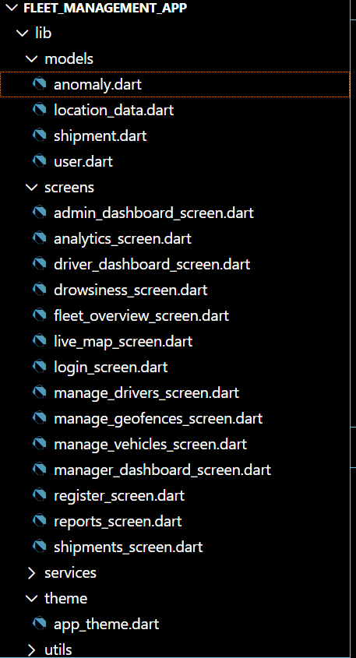
The figure above shows the application structures that built the fleet management app to be a success.
Tools/Software Used
- Flutter – Provider for dependency injection
- VS Code – Project organization
- Dart – MVVM-like architecture with models, services, screens, widgets
Personal Reflection
Separating logic from UI makes the code maintainable. Services handle Firebase, screens only build UI, models define data shapes. The architecture is clean and scalable.
Week 8: Project Planning
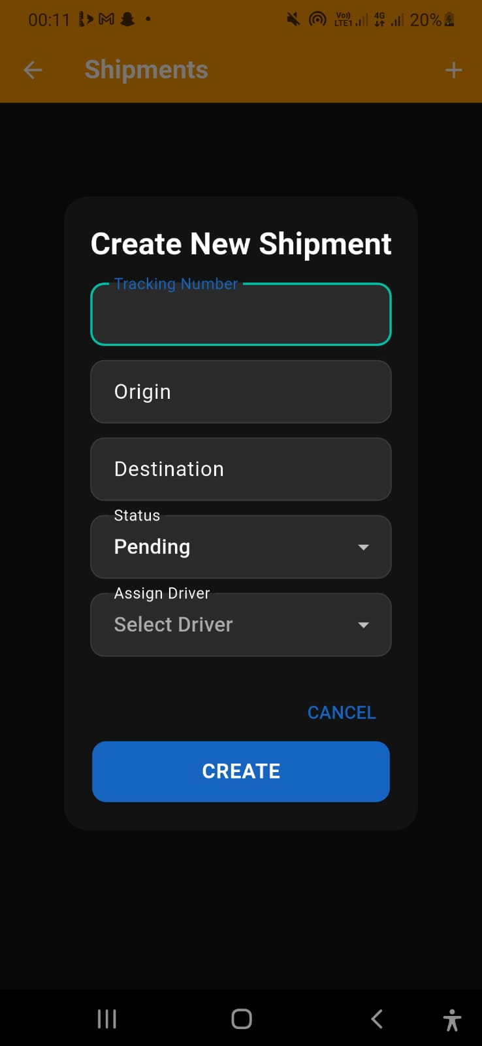
This figure above the manager is able to assign shipments to the drivers, checking whether it is pending, delivered, in transit or cancelled and also be able to update the status of delivery in case of any changes.
Tools/Software Used
- Microsoft Word-Export Pdf Report
- GitHub Projects – Issue tracking and milestones
- Google Docs – Requirements documentation
- Notion – Notes and brainstorming
Personal Reflection
Planning saved me from chaos. The planning kept me on track. Milestones helped me prioritize features like GPS and anomaly detection. I knew exactly what to build each week.
Week 9: Device Features and Sensors




FIG 9:1: GPS toggle icon – Before: Red (GPS OFF); After: Green (GPS ON) with Chip change.
Tools/Software Used
- Geolocator package – geolocator: ^13.0.2
- Firebase Realtime Database – firebase database: ^11.3.0
- Flutter permission handler – Runtime permission requests
- Android Manifest – Permission declarations
Personal Reflection
GPS is the heart of fleet tracking. Requesting permissions on Android 12+ was tricky but solved. Realtime Database update’s location every 5 seconds – perfect for live tracking.
Week 10: Notifications and Background Services
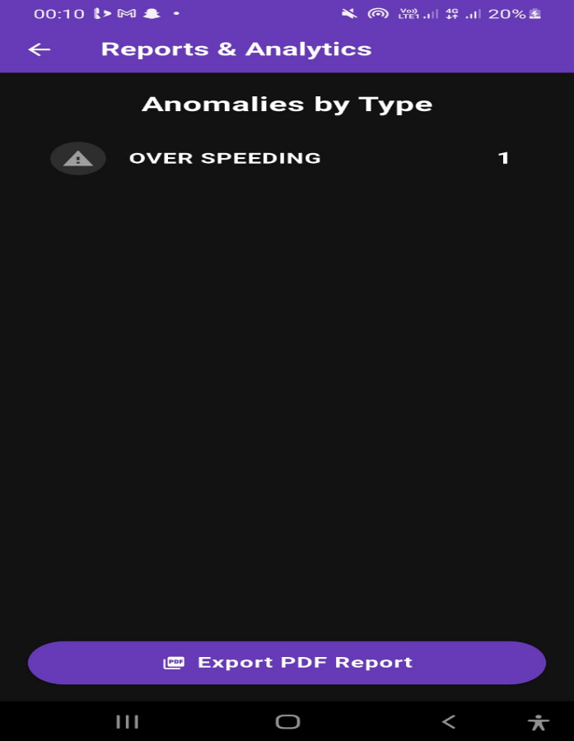
The figure above show anomaly alert of Over speeding detected in the manager’s dashboard.
Tools/Software Used
- Firebase Cloud Messaging – firebase messaging: ^15.2.0
- flutter_local_notifications – flutter_local_notifications: ^16.3.0
- Android Manifest – Background service permissions
- VS Code – Code implementation
Personal Reflection
Push notifications keep managers instantly aware of anomalies. Background location requires careful battery optimization but works well. FCM integration was straightforward.
Week 11: Mobile Security
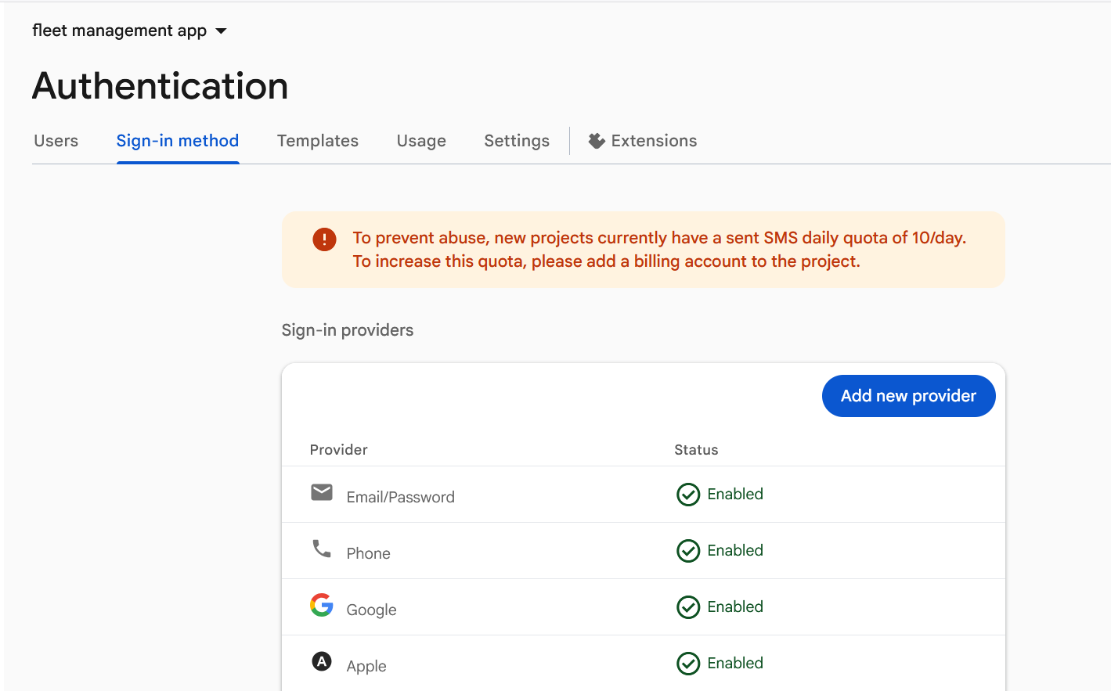
The above figure shows only the authenticated sig in methods that are enabled in the firebase.
Tools/Software Used
- Firebase Authentication – Email/Password sign-in
- Fire store Security Rules – Database-level access control
- Provider – Role-based UI rendering
- Firebase Console – Security rule management
Personal Reflection
Security rules are critical. Users can only see their own data (drivers) or all data (managers/admins). Firebase Auth handles passwords securely. Role-based routing works perfectly.
Week 12: Testing and Debugging
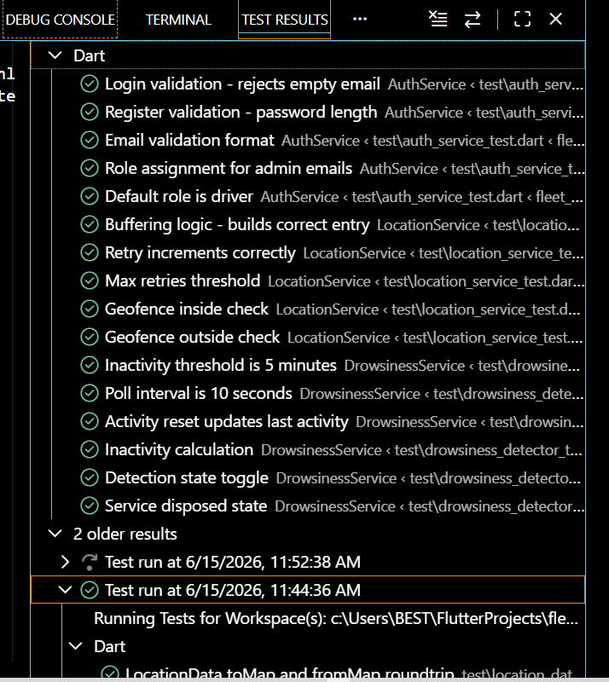

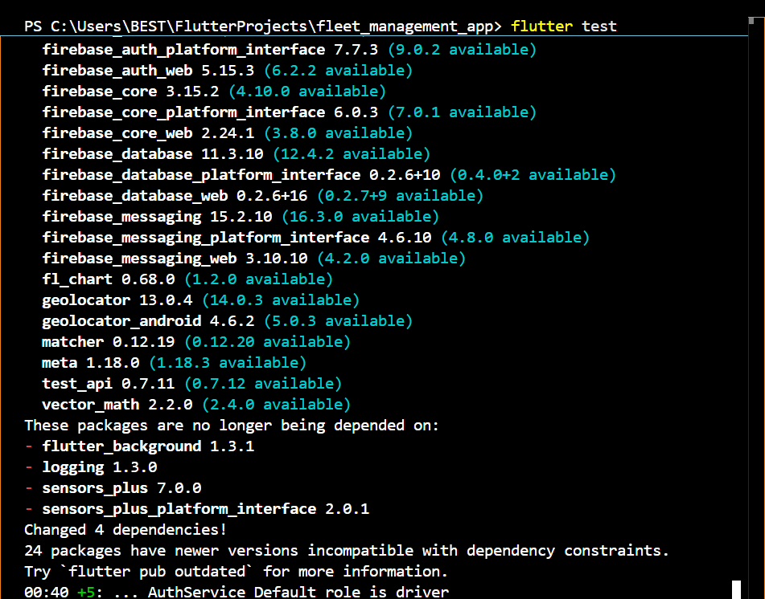

The Figures above show running tests for anomaly detection.

Tools/Software Used

Flutter DevTools – Widget inspector, performance view

VS Code Debugger – Breakpoints and step-through debugging

Print / debug Print – Logging

Flutter Test – Unit testing framework

Personal Reflection

Debugging layout issues was hard. DevTools widget inspector saved me. Physical device testing is essential for GPS. The overflow fix (SingleChildScrollView) worked perfectly.

Week 13: Application Deployment
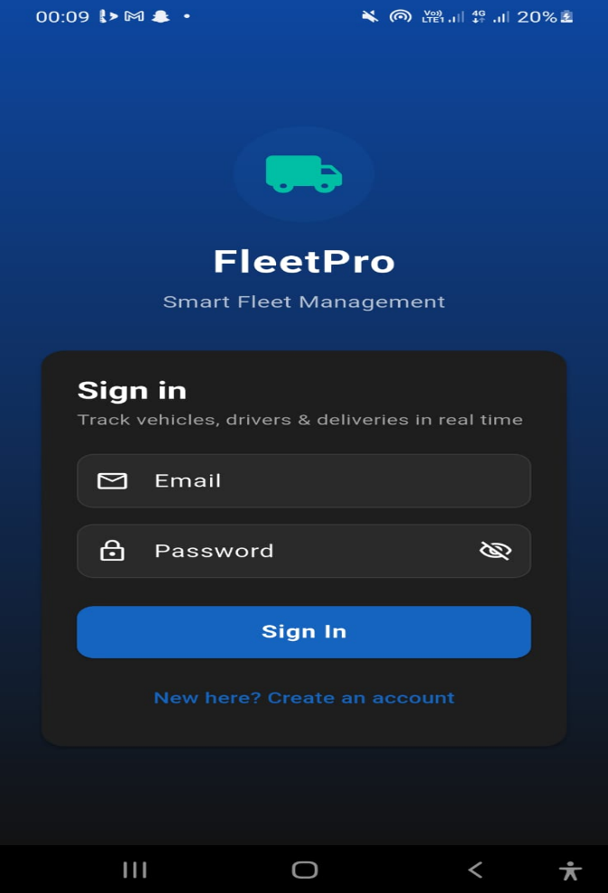

The figure above shows that the app was built successfully on my android(Fleet App icon).
Tools/Software Used
- Flutter CLI – flutter build apk
- Android SDK – Build tools
- Samsung Phone – Testing
- File Explorer – APK file location
Personal Reflection
"Building the APK was straightforward. The app runs smoothly on my Samsung phone. For release, I would need a proper key store. The debug APK is sufficient for demonstration."
Week 14: Final Project Presentation

Semester Project Tracking

Project Title

AI-Powered Fleet Management System with Real-Time Monitoring and Anomaly Detection

Project Objectives

Web dashboard for managers (add vehicles, drivers, shipments, reports).

Driver mobile app (delivery tasks, GPS location, anomaly alerts).

Manager mobile app (live fleet map, push notifications).

Real-time GPS tracking + geofencing (unauthorized zone alerts).

AI anomaly detection (over speeding, harsh braking, idle >10 min, drowsiness).
Project Requirements
- Functional: User roles (driver/manager/admin), live map, anomaly feed, shipment management, geofence creation, GPS tracking.
- Non-functional: Real-time updates (<2 sec), offline caching, secure authentication, scalable to 1M+ transactions (theoretically).
- Tech stack: Flutter (Dart), Firebase Auth, Fire store, Realtime Database, Google Maps, Geolocator.

Development Milestones
Week | Milestone
1-2 | Environment setup, Flutter project created, Firebase project created
3-4 | UI screens (login, register, driver/manager dashboards)
5-6 | Firebase integration (Auth, Fire store, Realtime Database)
7 | GPS location service + anomaly detection (over speeding, idle)
8 | Manager live map (Realtime Database)
9 | Geofencing and route deviation detection
10 | Push notifications + background location
11-12 | Admin panel + security rules + testing
13 | APK build and documentation
14 | Final presentation

Testing Results

Unit tests: Anomaly detection logic passed (speed limit, idle threshold).

Integration tests: Login → dashboard navigation works (driver/manager/admin).

Device tests: GPS tracking sends location every 5 sec; geofence alerts appear in anomaly feed.

UI tests: No overflow errors after fixes (overflow fixed by SingleChildScrollView).
Lessons Learned
- Use a physical device for GPS development – emulator location is unreliable.
- Firebase Realtime Database is ideal for live location streaming.
- Provider is simple but for larger apps consider Riverpod.
- Layout overflow is fixed by wrapping content in a SingleChildScrollView or using Expanded correctly.
Future Improvements
- Add driver drowsiness detection using the phone’s camera (real AI).
- Implement route optimization using Google Directions API.
- Add fuel consumption tracking via manual input or OBD.
- Web dashboard (same Flutter code) for desktop managers.
- Offline mode – store anomalies locally when network is lost.
End of Semester Reflection
Summary of Skills Acquired
- Flutter/Dart: Full app development (UI, navigation, state management, maps, location).
- Firebase: Authentication, Fire store (NoSQL), Realtime Database, Cloud Messaging.
- UI/UX: Material Design, responsive layouts, dark theme.

- Data structures: Applied hash tables, trees, queues, heaps in billing/donation system analysis.
- Tools: VS Code, Android Studio, Git, Firebase Console.

Most Interesting Topic
Real-time anomaly detection – combining GPS data with simple heuristics (speed, idle time) felt like AI in action, and seeing alerts appear instantly on the manager’s map was very satisfying.

Major Challenges Faced

Flutter Fire CLI setup – PATH issues, Node.js installation, execution policy errors.

Emulator not connecting – fixed by using a physical device.

Disk space full during build – cleared Gradle caches.

Google Maps API key configuration for Android.

Background location permissions on Android 12+.
How Challenges Were Overcome
- Followed step-by-step online guides (Stack Overflow, Flutter docs).
- Switched to physical device with USB debugging.
- Deleted temporary files and moved caches to D: drive.
- Requested API key from Google Cloud Console and added to AndroidManifest.xml.
- Added ACCESS_BACKGROUND_LOCATION permission and explained in app.

Professional Growth Achieved

Gained confidence in full-stack mobile development.

Understood tradeoffs between different data structures (hash table vs. tree).

Learned how to debug complex issues (network, permissions, concurrency).

Improved documentation and presentation skills.

Overall Course Experience
This project bridged theory (data structures, algorithms) and practice (real app with 1M+ transaction scalability). The hands-on approach made abstract concepts tangible. I now feel prepared to build production-ready Flutter apps and contribute to open-source mobile projects.

Final Approval
Student Name: GRACE MUINDI
Student Signature: Muindi
Date: 13/06/2024
Lecturer Name: MR MICHAEL NYORO
Lecturer Remarks: _____________________
Date: _________________________________

Semester Project Tracking

Project Title

Project Objectives

Project Requirements

Development Milestones

Testing Results

Lessons Learned

Future Improvements

End of Semester Reflection

Summary of Skills Acquired

Most Interesting Topic

Major Challenges Faced

How Challenges Were Overcome

Professional Growth Achieved

Overall Course Experience

Final Approval

